Press Release: Nazir Sabir @ Adams

Adams State Adventure Program is proud to invite Nazir Sabir to the Adams State University Campus. Nazir is the first Pakistani mountaineer to conquer Mt. Everest & K2. He has been honored worldwide and is recognized with the likes of Reinhold Messner for first ascents & speed ascents. Hailing from the Hunza mountains of Pakistan, Nazir’s life has been one long adventure filled with narrow escapes and successful summit attempts. His presentations have been called “Captivating” and “enthralling”. Don’t miss this opportunity to learn about the Northern region of Pakistan, its politics, people and mountains!
When: Wednesday October 17th at 7:00pm -10pm
Where: Adams State University Campus: Richardson Hall Auditorium
Tickets are free and available at the Adams State Adventure Programs headquarters on Monterey Ave. Or Call 587-7813
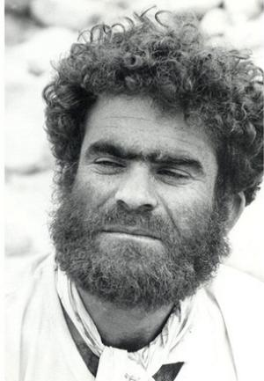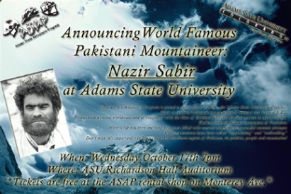*
*Digital Slick available on request (leviwilner@adams.edu)*

